🎓

GradePilot: Advanced Analytics for Educational Performance Prediction

SSSS
BY
PATAJO, Odrei John C.
DE LEON, Queenie A.
NOVELOZO, Racell Jay C.
MANAHAN, John Felix R.
OCHOCO, John Patrick B.

- DATA UNDERSTANDING AND PREPARATION
This section involves exploring and familiarizing with the dataset used for GradePilot. It includes understanding data structure, identifying variable types, and checking data quality before analysis.

- DATA LOADING
This step covers the process of importing data into the analytical environment, ensuring that it is properly formatted and ready for further processing.
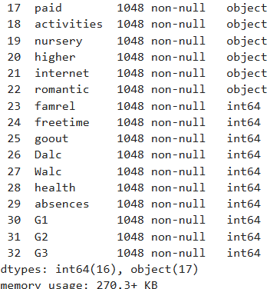
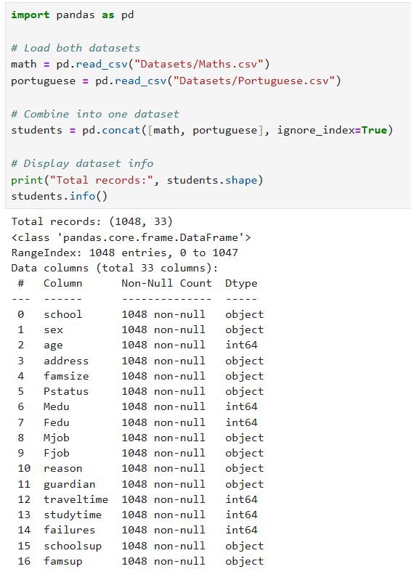

- EXPLORATORY DATA ANALYSIS (EDA)
EDA is used to visually and statistically explore the dataset to identify patterns, relationships, and anomalies. It provides insights that guide later modeling decisions.
- Distribution of Final Grades
This visualization shows how student grades are distributed, helping identify trends such as grade concentration or imbalance.
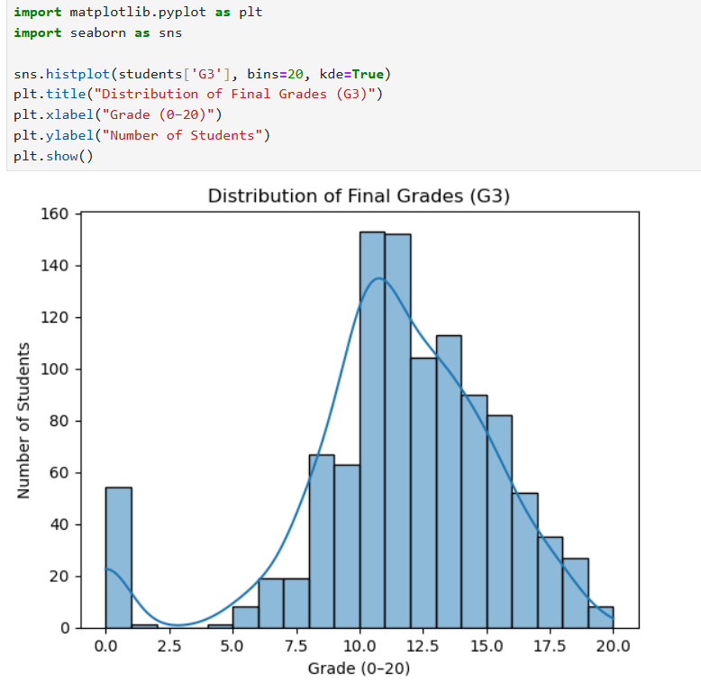

- Study Time vs Final Grade
This chart explores the relationship between study time and students' final grades, highlighting how effort impacts performance.
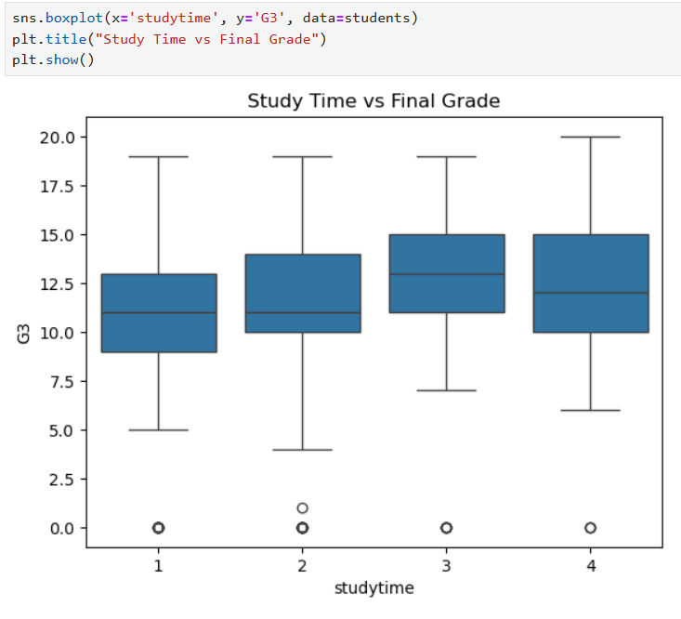

- Correlation Heatmap
A correlation heatmap visualizes the relationships between numerical variables, identifying which features are most related to the target variable.
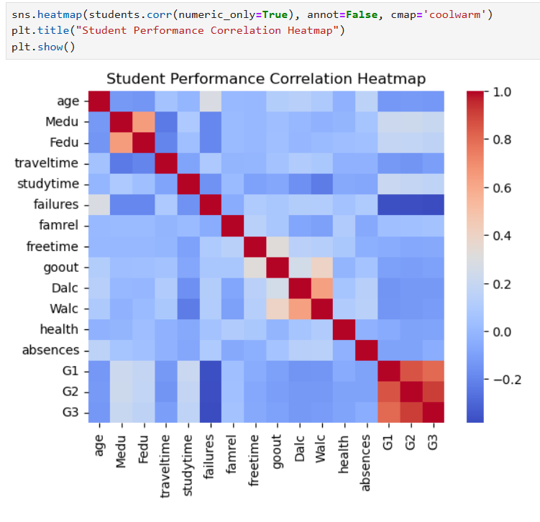

- DATA PREPROCESSING
This step focuses on preparing the data for modeling. It involves cleaning, transforming, and splitting data into usable forms.

Handling Missing Values
Missing values are detected and appropriately managed, either through imputation or removal, to maintain data consistency.
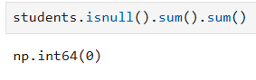

- Encoding Categorical Variables
Categorical variables are converted into numeric form using encoding techniques to make them compatible with machine learning algorithms.
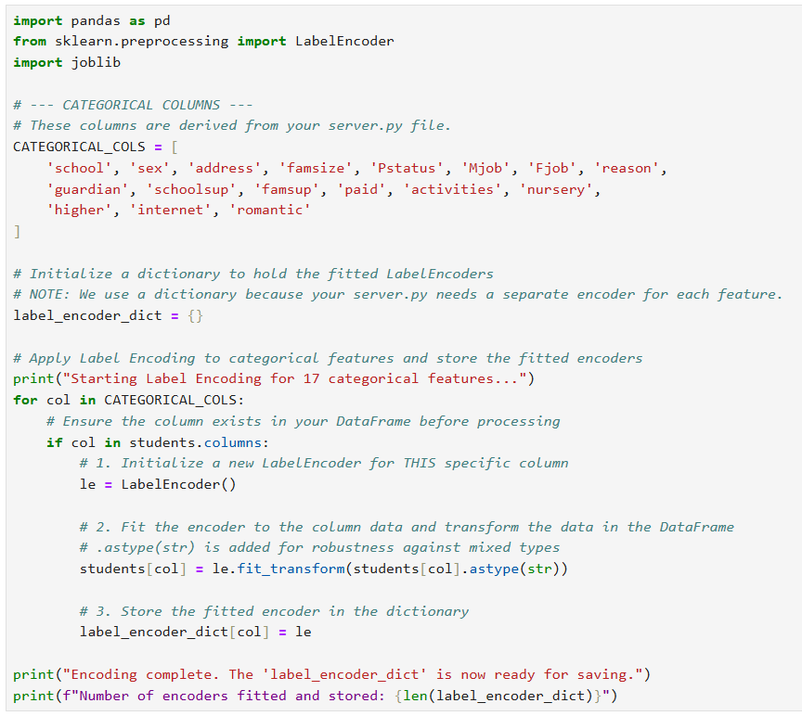

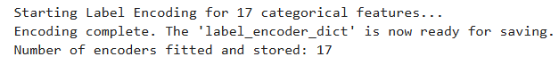

- Feature Scaling / Normalization
Feature scaling ensures that all numeric features have comparable scales, improving model accuracy and performance.
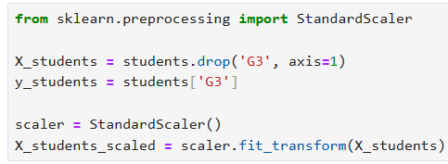

- Train–Test Split
The dataset is divided into training and testing subsets to evaluate model performance on unseen data.

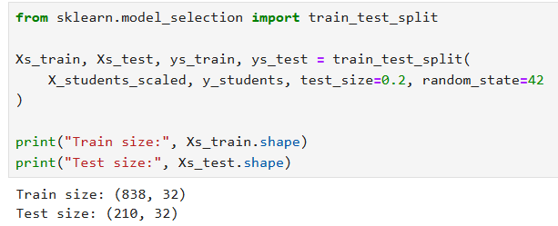

- MODEL IMPLEMENTAION
This section describes the implementation of various machine learning models to predict student grades based on the prepared data.

- Initialize Models
This step initializes multiple models such as Decision Tree, Random Forest, and others for training and evaluation.
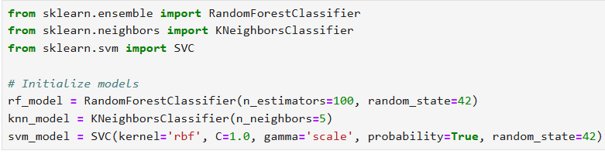

- Model Training Workflow
The training workflow involves fitting each model to the training data and recording performance metrics.
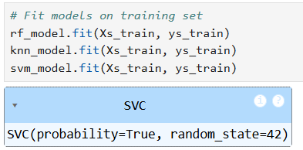

- Hyperparameter Tuning (Example: Random Forest)
Hyperparameter tuning optimizes model parameters to improve prediction accuracy and generalization.

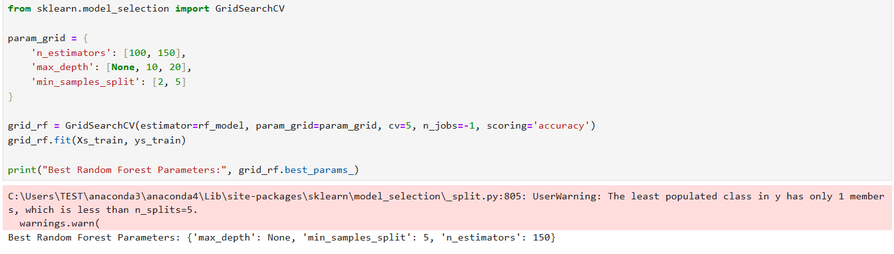

- MODEL EVALUATION
This section evaluates model performance using metrics like accuracy, precision, recall, and F1-score to determine effectiveness.

EVALUATION CODE
Contains code snippets or references to scripts used for testing model performance and generating results.
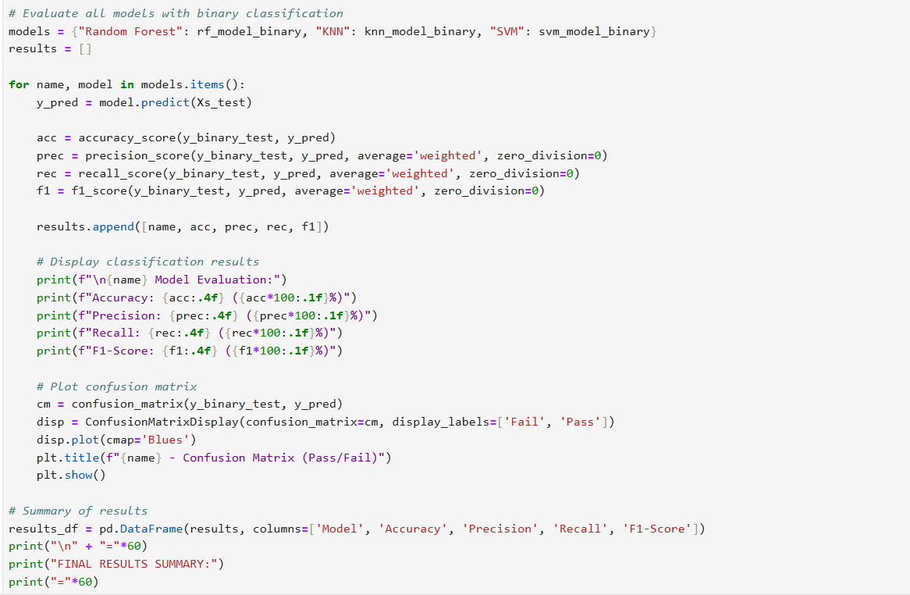
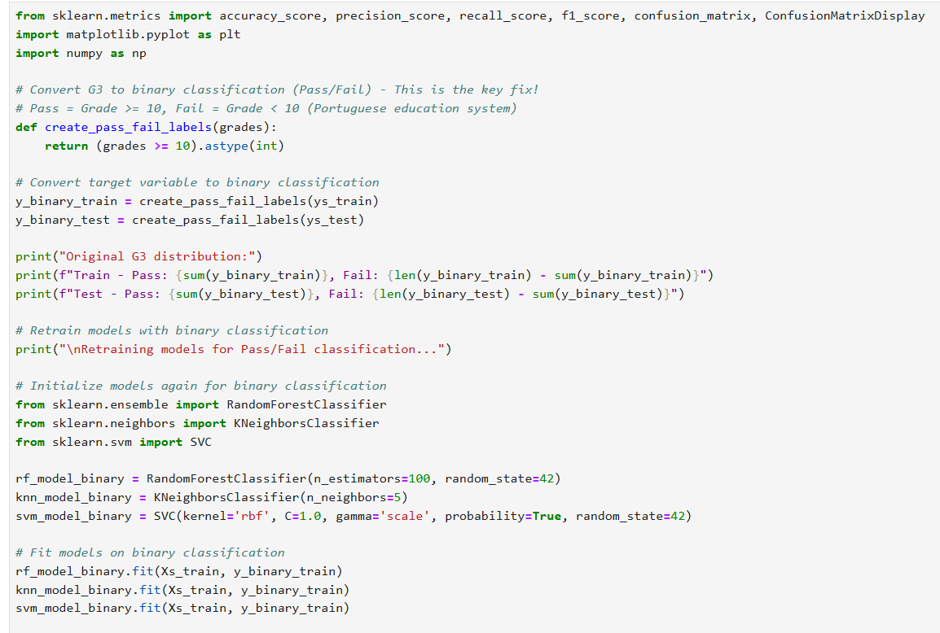

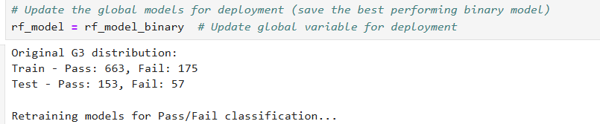

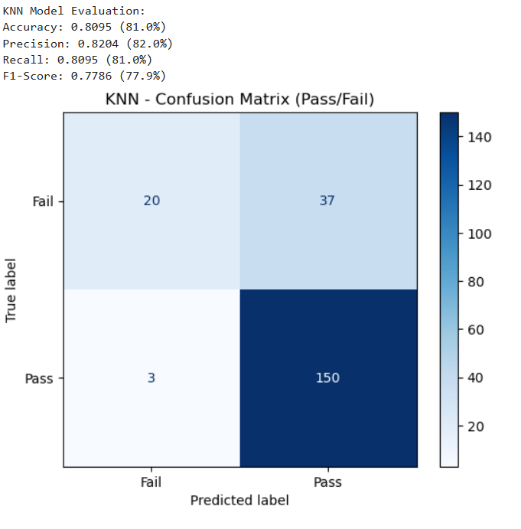
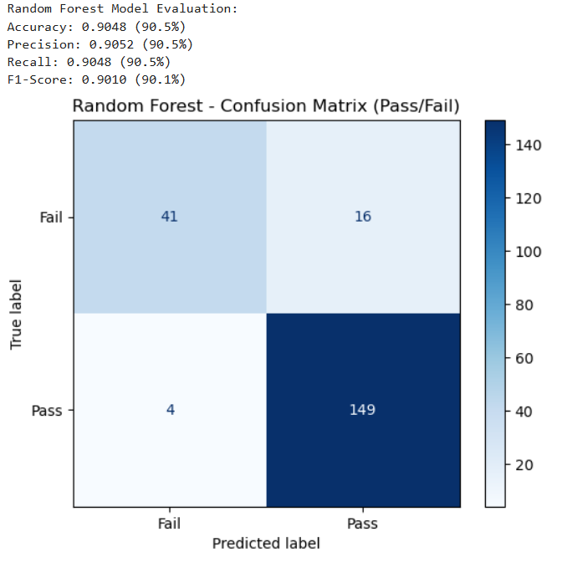

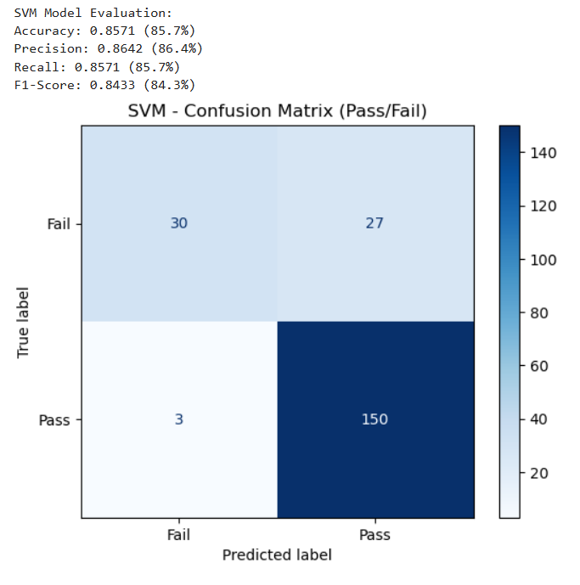

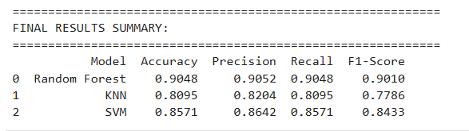

VISUALIZATION OF RESULTS
This section presents visual comparisons of model performances to easily identify the best-performing algorithm.

Model Performance Comparison
A comparison chart or table showing how each machine learning model performed on evaluation metrics.

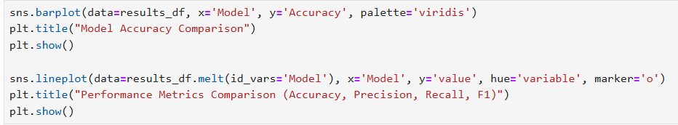
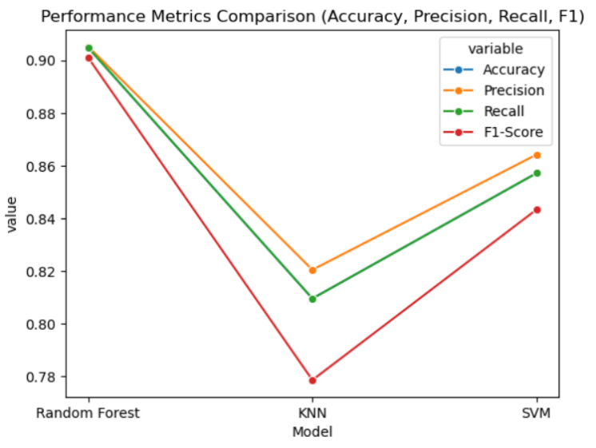
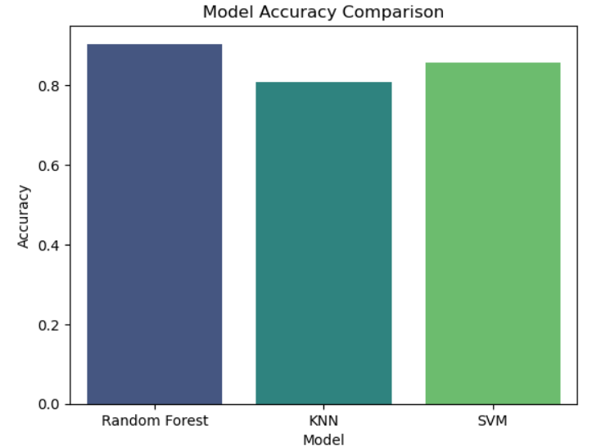

COMPARATIVE ANALYSIS & DISCUSSION

This part interprets the evaluation results and discusses differences between model performances and their implications.

Machine Learning Model Performance Comparison

Compares the accuracy and other metrics of different models used in the GradePilot system.

Model Performance Comparison
Highlights which model achieved the best results and why others may have underperformed.

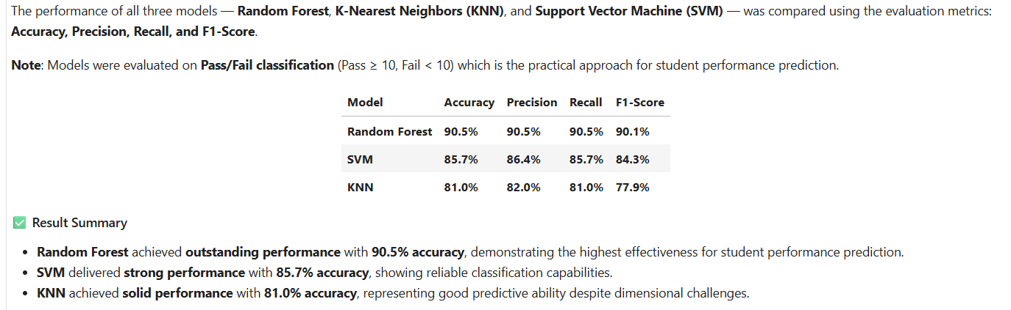

Discussion of Model Differences
Provides insights into why certain models performed better based on their algorithmic behavior and data characteristics.

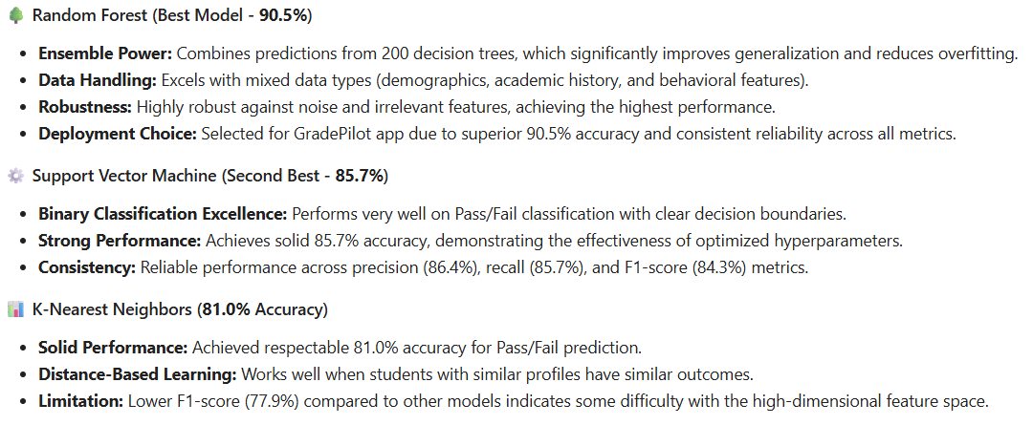

Key Findings
Summarizes the most important insights discovered from model performance and data analysis.

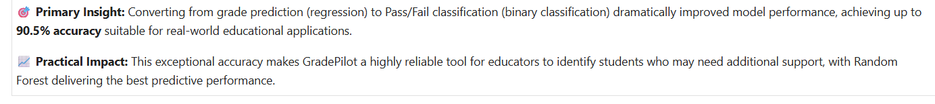

MODEL DEPLOYMENT
This section explains how the chosen model is deployed into a usable system for grade prediction.

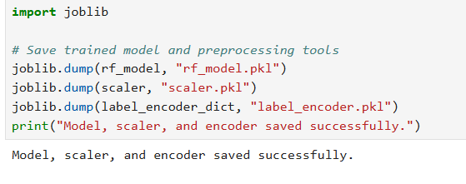

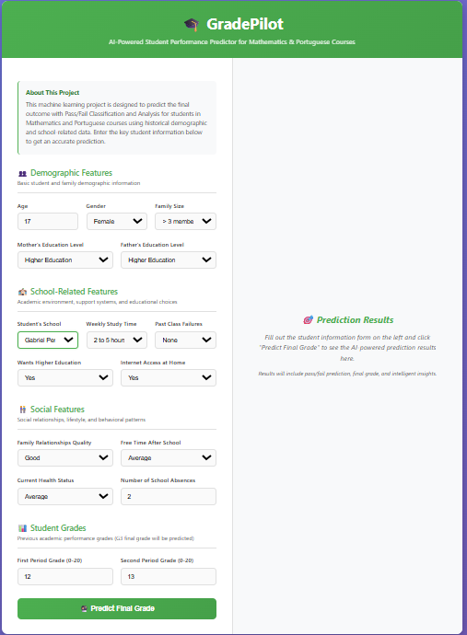
Web App of GradePilot
Overview: Gives a high-level view of how the GradePilot prediction system operates from input to output.

First: The user inputs Demographic Features data for grade prediction.

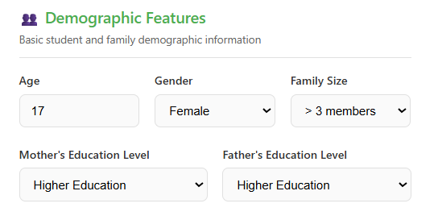

Next: Then it handles data validation and preprocessing before feeding it into the prediction model.

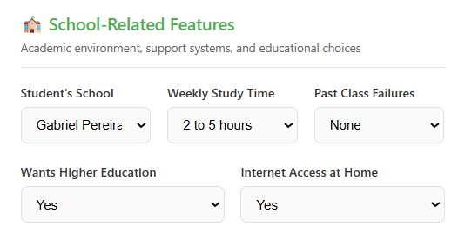

Next: Then it handles data validation and preprocessing before feeding it into the prediction model.

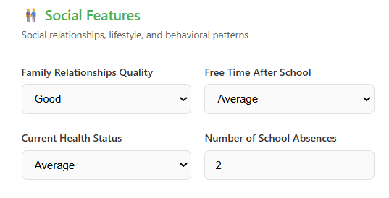
Next: Then it handles data validation and preprocessing before feeding it into the prediction model.
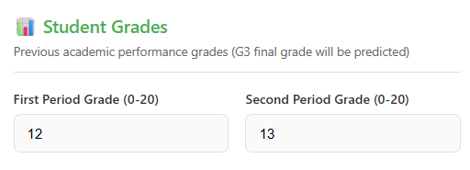

Last: Then when you all done fill up, click the ( “Predict Final Grade” ). The Final output step where the system provides the grade prediction result indicating whether the student is likely to pass or fail.
